*Account: LamDN3*

**Em xin nộp phần Practise Codelearn_JS Part2**

* ***Đề bài ạ :*** <https://codelearn.io/training/detail/2790758>
* ***Submit ạ***

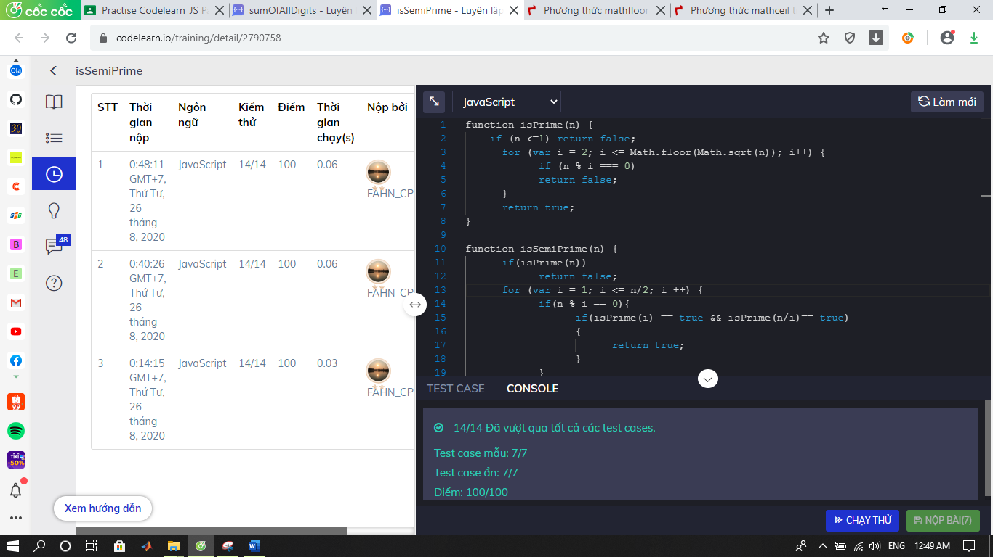

* ***Đề bài ạ:*** <https://codelearn.io/training/detail/2471637>
* ***Submit ạ:***

